

databases assıgnment 1

Candidate No: 181509



October 18, 2018

unıversıty of sussex

Question 1:

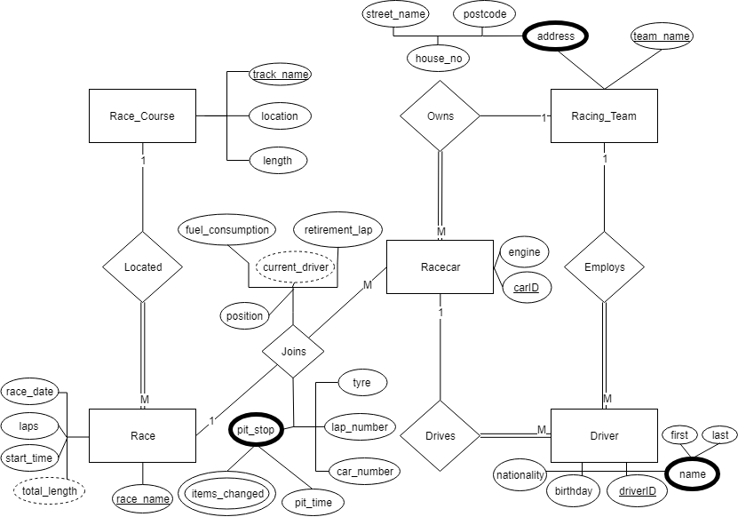

I assumed that a racecar that is racing for a team would be on the track regardless the driver, that’s why I haven’t connected driver to race entity directly. For example, in 2018 season cars which belong to Ferrari, numbers 5 and 7, were driven by Sebastian Vettel and Kimi Raikonnen but in 2019 season Ferrari can give the car 7 to their new driver Charles Leclerc which indicates that actually a car races rather than a driver.

I assumed attributes that are connected to “Joins” relationship would change for each “Race”.

Question 2:

Cardinality Constraint:

A Studio can Produce many Movies.

A Movie can be produced by one Studio.

Participation Constraint:

A Studio may Produce movies.

A Movie must be Produced By a Studio.

Explanation:

As in real life scenarios, a movie studio may exist without any projects alive, but a movie cannot exist without its studio. A movie is produced by only one studio where a studio can make any number of movies.

Cardinality Constraint:

An Actor can Star In many Movies.

A Movie can be Starred by many Actors.

Participation Constraint:

An Actor may Star In a Movie.

A Movie must be Starred by an Actor.

Explanation:

Movies can have many actors and they must at least have one actor. An actor may take place in many movies but some actors may not take place in some movies at all.

Cardinality Constraint:

An Original Movie can be Sequeled by many Sequel Movies.

A Sequel Movie can be Sequel Of one Original Movie.

Participation Constraint:

An Original Movie may be Sequeled By a Sequel Movie.

A Sequel Movie may be Sequel Of a Original Movie.

Explanation:

An original movie may or may not have a following sequel movie. Original movies can have any number of sequel movies. A sequel movie, if it has no original movie then itself would be an original movie, can have only one origin movie it is based on.

Question 3:

Studio (name, phone, movie id)

**primary key** name

**foreign** **key** movie id **references** Movie (movie id)

Movie (movie id, title, name, original)

**primary key** movie id

**foreign** **key** name **references** Studio (name)

**foreign** **key** original **references** Movie (movie id)

name **not null**

Producers (producer, movie id)

**foreign** **key** movie id **references** Movie (movie id)

Stars_in (fname, lname, movie id, award)

**foreign key** movie id **references** Movie (movie id)

**foreign** **key** fname, lname **references** Actor (fname, lname)

fname, lname **not** **null**

Actor (fname, lname, gender, dob)

**primary** **key** (fname, lname)